**Instructions on how to update the Wellbeing Economy Monitor with new data**

**Part A. How to update all the tabs except the Home Page.**

The process of updating the application is two-step for each figure/table:

1. Locate the right excel spreadsheet

The spreadsheets are located in the folder titled ‘www’:

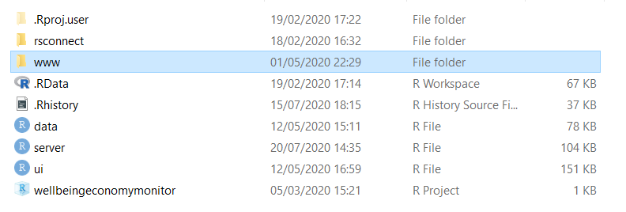

Here, each sub-tab has a dedicated sub-folder:

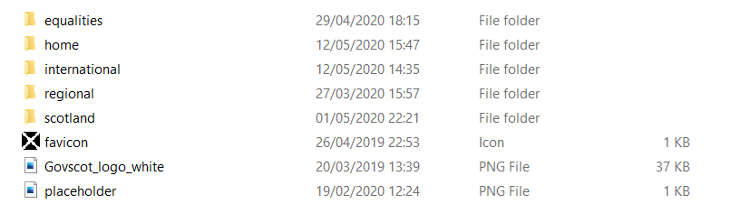

Data for all tabs except the home page and the equalities tab is located in the three folders:

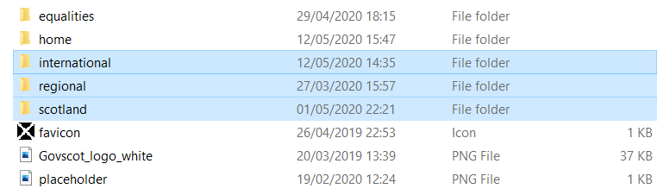

As an example, in order to update the growth figure from Productivity tab for international data, one would locate the following:

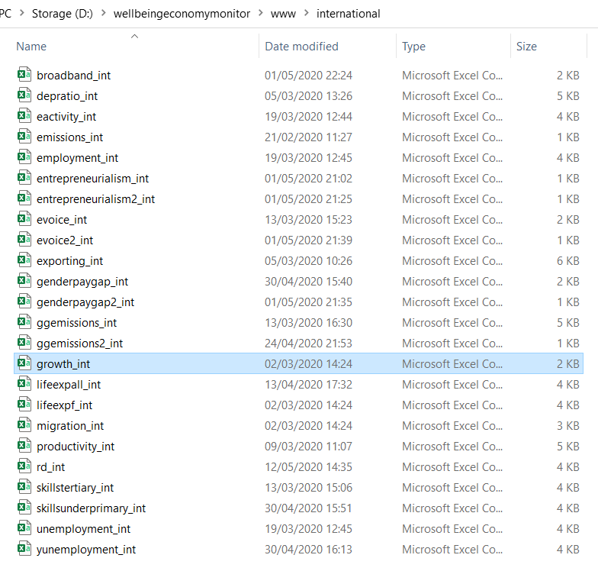

Once located, all that is needed to do is to append the table with column for new year:

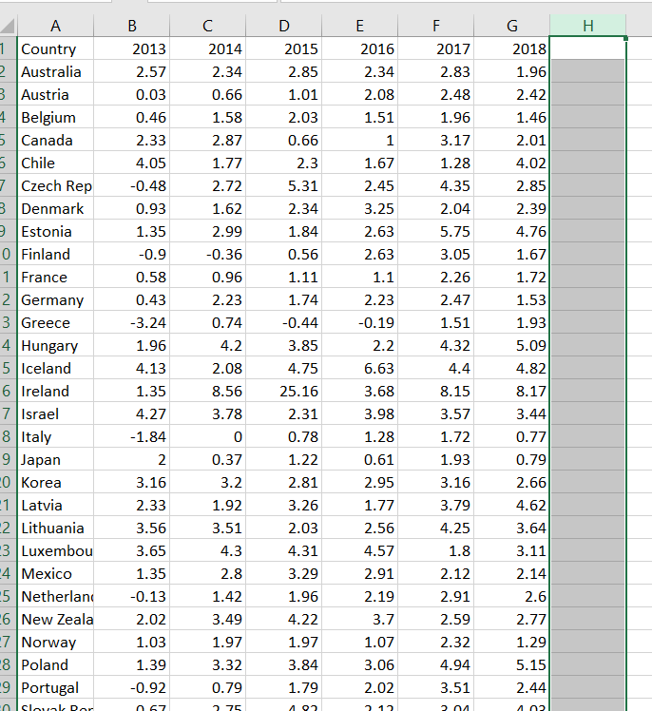

That is all. No changes to the source code should be necessary.

1. Paste data for new year

Please note that each piece of data visualisation in the app is paired with hyperlink that allows for finding the data in the relevant location on the Internet (most data comes from the Open Data Platform, OECD and the Eurostat):

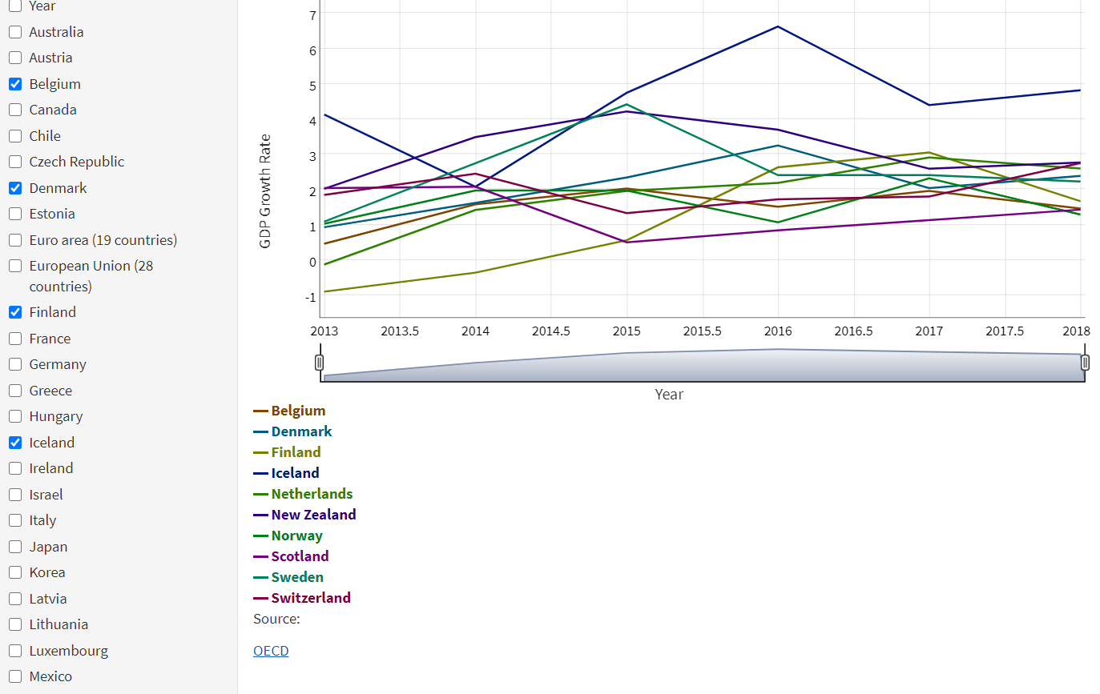

**Part B. How to update the Home Page**

Please locate the following folder: 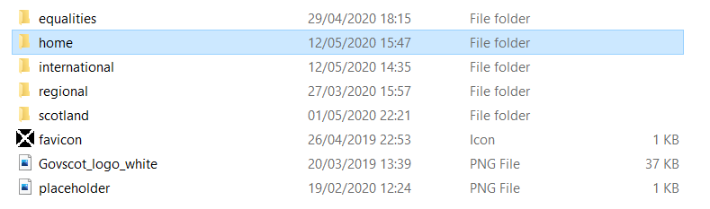

There one will find two spreadsheets:



The spreadsheet titled “home” contains all the information that is displayed in the text in the home page. The application does not load that spreadsheet. It has been created as a help to manually feed the figures in the source code. 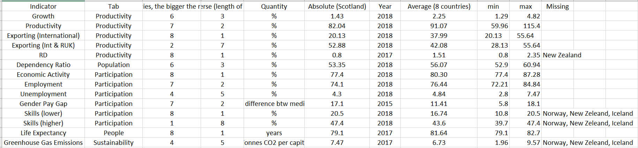

One of the columns:

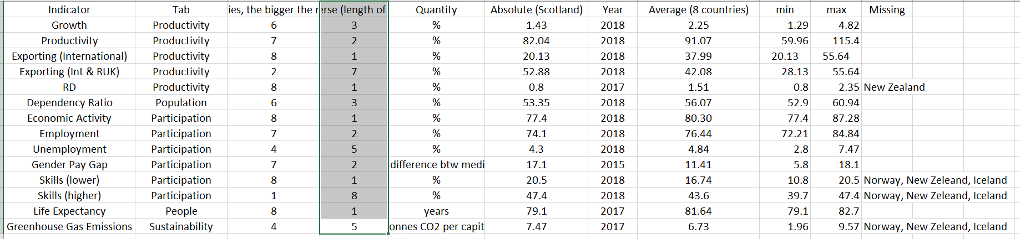

Should be copied and pasted into the spreadsheet titled “sunburst_home_e”:

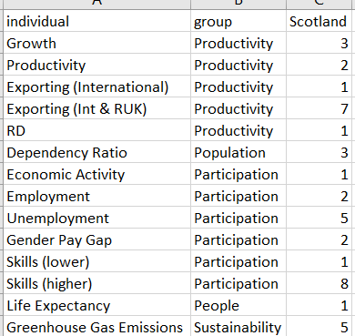

When this is done, the application will give the sunbursts’ bars appropriate lengths:

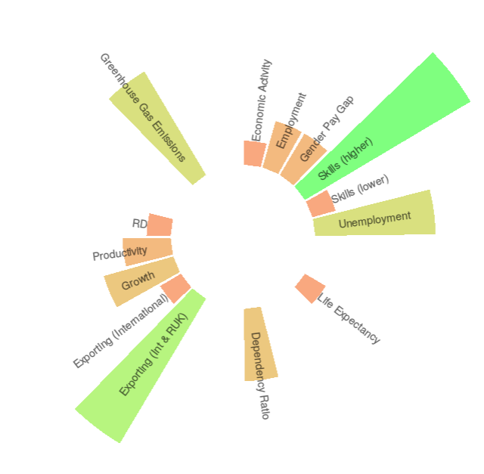

In order to update the figures displayed in the text on the Home Page please locate the file titled “ui”:

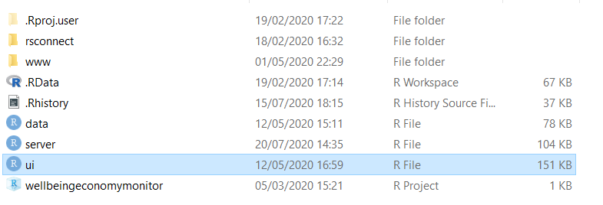

Comments divide the lengthy source code into neat sections. For the purpose of updating the home page, one only needs to modify the home page part.

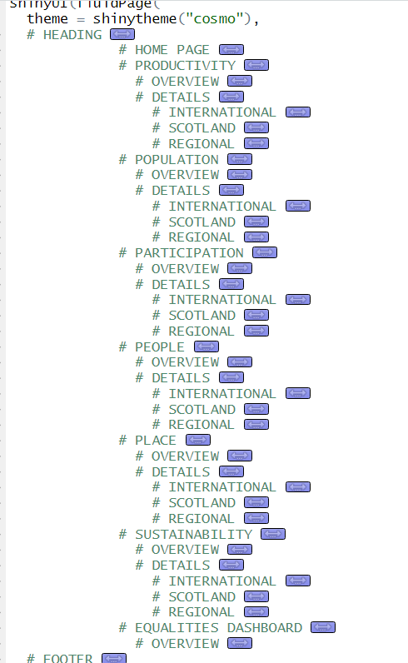

Please note that the data from the “home” spreadsheet is now handy in filling the figures in the source code:

